# 8D RUSIA UZBEKISTAN

# Combination of Russia and Uzbekistan, 2019 year, (8 days, Thu-Thu option)

**Tour highlights:**

1. Visiting Peter and Pauls fortress
2. Visiting world famous Hermitage
3. Visiting Kazan Cathedral
4. Visiting Kremlin
5. Visiting Grand mosques of Petersburg and Moscow
6. Visiting Al Bukhary memorial complex in Samarkand
7. Visiting Bahauddin Naqshbandy complex in Bukhara
8. Pilaw master class in Bukhara
9. Pottery master class in Gijduvan
10. Shish kebabs master class in Gijduvan
11. Cultural show “Uzbek Bride” in Samarkand.
12. Visiting Hasti Imam Complex in Tashkent with original Othman Quran.

# Day 0, Wed: Singapore / Kuala Lumpur – Tashkent

Flight from Singapore or Kuala Lumpur to Tashkent by Uzbekistan airways flight: From Kuala Lumpur, departure is at 18:35, from Singapore departure is at 22:05. Overnight flight.

# Day 1, Thu: Tashkent – Saint Petersburg

Arrival to Tashkent international airport at 03:20 am local time from Singapore / Kuala Lumpur flight. Transit and flight for Saint Petersburg by Uzbek airways flight at 06:20. Arrival Saint Petersburg airport at 09:30 local time. Meet by your escort guide and transfer to the hotel. Check in and time for rest at the hotel. City tour in Saint Petersburg: During the tour, you will be taken out on the extra-comfortable bus, which will take you to the most precious monuments of the city’s rich history and original architecture carefully preserved as the world cultural heritage. During this panoramic city-tour of Saint Petersburg, you will be able to hear amazing stories and to take fine pictures of the main architectural and historical sites like Nevsky prospect, the Kazan Cathedral, the Winter Palace, Vasilievsky Island, St. Isaac Cathedral, Peter and Paul Fortress, the Senate Square and the Palace Square Lunch and dinners are at local restaurants. Overnight is at the hotel.

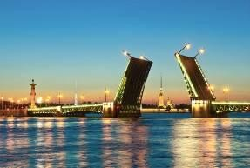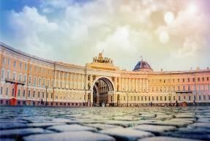

# Day 2, Fri: Saint Petersburg – Moscow (Sapsan train)

Breakfast is at the hotel. City tour in Saint Petersburg: Hermitage Museum (main building). It is hard to imagine a trip to Saint Petersburg without visiting one of the most famous museums worldwide – the State Hermitage. Its priceless collection occupies five historical buildings of which the Winter Palace – the former residence of the Russian Royal family – is the most remarkable. Its rooms, decorated with marble and gold provide a fine background for the

treasures of the Hermitage. Lunch will be at local restaurant. Kazan Cathedral - was built in 1811 and is usually associated with Russia’s victory over Napoleon in 1812. Transfer to railway station, board and departure for Moscow by fast train Sapsan. Upon arrival transfer for dinner at local restaurant, later on transfer to your hotel, check in and overnight is at the hotel.

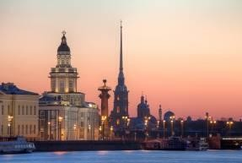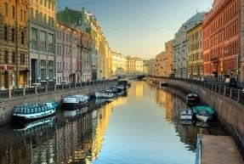

# Day 3, Sat: Moscow

Breakfast at the hotel. City tour in Moscow: Moscow is the capital of the Russian Federation and represents a unique set of old architecture masterpieces and modern high-tech buildings. During the excursion, you will visit Red Square, the Kremlin, the Victory Park, the White House, the Arbat, Christ-the-Saviour Cathedral, the observation platform of Sparrow hills, Lomonosov University… and much more! It is an interesting and efficient introduction to Europe’s biggest city. Lunch and dinner will be at local halal restaurants. Overnight is at the hote l.

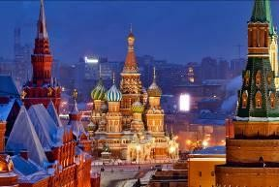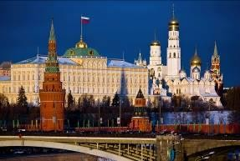

# Day 4, Sun: Moscow – Bukhara (flight)

Breakfast is at the hotel. Transfer to Moscow airport, registration and flight for Bukhara (Uzbekistan airways flight 15:05-20:55). Lunch is on board. Upon arrival transfer for dinner. Dinner at local restaurant. Transfer to your hotel, check in and overnight is at the hotel.

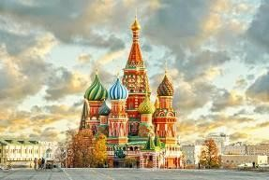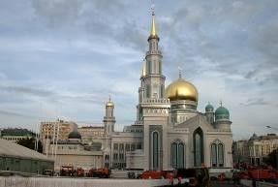

# Day 5, Mon: Bukhara

Today you will have a full day city tour in this fascinating city. At first you will visit the most ancient citadel in Bukhara dating back to the 4th century named Citadel Ark which served as a palace for several dynasties of Bukhara Empire. Then you will see Samanids mausoleum, a real masterpiece of architecture of 9th -10th century. Then the tour continues to Chashma Ayub, meaning Job's well and Bolo-Hauz mosque, known also as the mosque of forty columns built in honor of Bukhara governor Abu-Fayud Khan. Then you have a chance to walk along the shopping domes and visit one of the most famous madrasahs of Bukhara called Nodir Divan Begi which is also a part of Lyabi House Ensemble, famous central sightseeing of Bukhara. The tour will end with visiting Poi Kalon complex, the unique sample of architectural art of Bukhara. It consists of three structures built in the 12th - 16th centuries: Kalon minaret, Kalon mosque and Mir Arab Madrasah. Night is in a hotel.

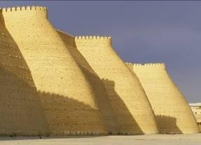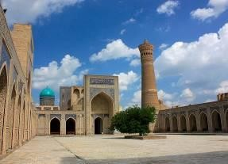

# Day 6, Tue: Bukhara – Gijduvan - Samarkand (290 km, 4 hours)

After the breakfast, we will start our way to Samarkand. On the way, we will stop over at Gijduvan village to visit famous private pottery workshop, which was previously visited by Mrs. Hillary Clinton, Sir Charles and many of other famous people. There we will have a chance to learn the history of pottery culture of Uzbekistan, short master class of pottery preparing and do buy the items you liked. Lunch will be at Pottery house, groups will have master class of Gijduvan shish kebabs, local bread preparing process. Afterwards continue drive to Samarkand. En route visiting memorial complex of Al Bukhary. Al Bukhary was an Islamic scholar, who authored the hadith collection known as Sahih al-Bukhari, regarded by Sunni Muslims as one Upon arrival check in to the hotel. Dinner will be at local restaurant. Overnight is at the hotel.

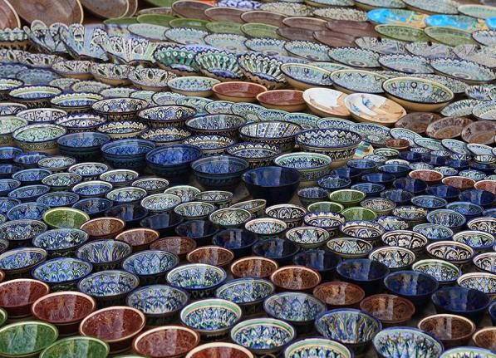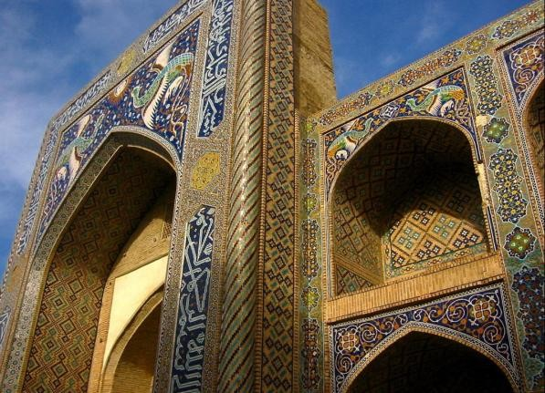

# Day 7, Wed: Samarkand – Tashkent (train)

Samarkand is situated in the valley of the river Zerafshan. It is the second largest city of Uzbekistan and is of the same age as the city of Babylon or Rome. Today you will visit its most

outstanding sights such as Registan square, Shakhi-Zindeh, Mausoleum Guri Emir and Bibi Khanum Mosque. Registan Square, a complex of three fascinating Madrasahs dating back to 15- 17th centuries, is the main highlight of Samarkand that no person can stop admiring its beauty and majesty. Architectural complex of Shakhi-Zindeh represents a big collection of mausoleums dating back to 11th-15 centuries being a part of a UNESCO World Heritage Site. Bibi Khanum Mosque was built in honor of favorite Tamerlane’s wife, after his successful campaign in India. Evening train to Tashkent. Overnight is at the hotel.

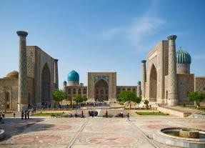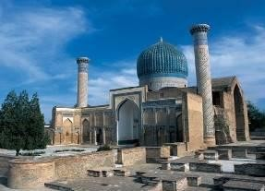

# Day 8, Thu: Tashkent – Flight

Full day is dedicated to a sightseeing tour in Tashkent. Today you will visit Independence square which is the main square of the country, erected as a symbol of victory over fascism in World War II. Then you will have a chance to walk along the local Broadway, a walking street between independence square and Amir Timur square. Further you can take a ride in famous Tashkent metro, among the most beautiful subways in the world. First line was opened in 1977. Then you will visit the old part of the city which includes: Chorsu Bazaar, Kukaldash Madrasah and Hast Imam complex that consists of several madrasahs, mosques and mausoleum. The highlight of its exhibits is the Othman Quran which is the world’s oldest Quran copy dating back to 8th c. Quran belonged to Othman Ibn Affan, the Third Caliph (of the four righteous Caliphs who succeeded the prophet Muhammad). Othman was killed by non- muslims in 8th century. His blood spred over the Quran that you still can see on its pages. Evening transfer to airport and flight home.

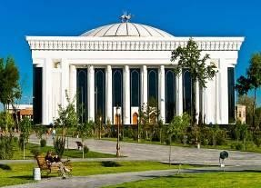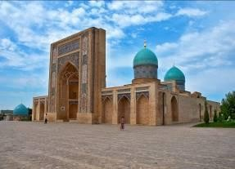

Pricing for contracted partners for 01.01.19-31.06.19 (except Law and Economical conferences’ dates in Russia):

|  |  |  |  |
| --- | --- | --- | --- |
| **Persons** | **Price per person in USD** | | |
|  | **Option A** | **Option B** | **Option C** |
| 10+1 Foc | 1070 | 1190 | 1530 |
| 15+1 Foc | 970 | 1080 | 1405 |
| 20+1 Foc | 905 | 1015 | 1330 |
| 25+1 Foc | 875 | 975 | 1285 |
| 30+1 Foc | 855 | 955 | 1265 |
| 35+1 Foc | 830 | 930 | 1235 |
| 40+1 Foc | 815 | 920 | 1220 |
| Single Supplement | 150 | 320 | 545 |

|  |  |  |  |  |
| --- | --- | --- | --- | --- |
| **Cities** | **Nights** | **Option A** | **Option B** | **Option C** |
| Petersburg | One | Ladoga 3* | Moscow 3* | Grand Emerald 5* |
| Moscow | Two | Izmaylovo Gama 3* | Izmaylovo Delta 4* | Golden Ring 5* |
| Bukhara | Two | Old City 3* | Omar Khayam 4* | Edem Plaza 4* |
| Samarkand | One | Ideal 3* | Diera 4* | Emirkhan 4* |
| Tashkent | One | Grand Orzu 3* | Ramada 4* | Miran 5* |

# Price includes:

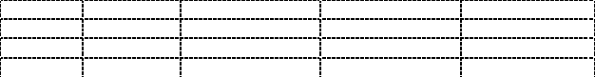

Accommodation at mentioned hotels on double share basis

Transportation per program in comfortable a/c transport with professional drivers Breakfasts at the hotels

All lunches and dinners per program

Master classes and show programs in Uzbekistan Daily two bottles of 0.5l water per person

Group tour leader in single room on Foc base (+1 Foc)

Escort English (Bahasa is as per request) speaking guide for entire tour in Uzbekistan and separate guides in Saint Petersburg and Moscow

Second class tickets for Sapsan fast train from Saint Petersburg to Moscow.

Economy class tickets for Afrosiab bullet train from Samarkand to Tashkent (if not available for our dates, company replace it by Registan or Nasaf train)

 Entrance fees to mentioned sights per program (excluding photo and video charges at sights)

Visa support to Uzbekistan (if required) Visa support to Russia

# Price does not include:

Visa consular fees and processing expenses Photo and video charges at sights International air tickets

Travel Insurance

Extras, not indicated in inclusions

# PS:

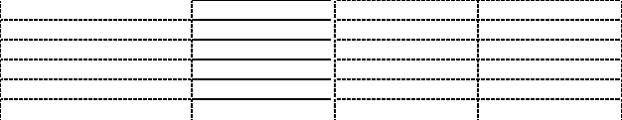





Pricing valid for contracted partners only for mentioned dates

If mentioned hotels are overbooked and not available, we will give appropriate alternative.

If there are no free seats in bullet trains, we will replace by normal train or do transfer by auto transport.

# Payment:

 Tour payment should be made not less than 40 days prior to tourist group arrival to our bank account as per sent invoice.

 The rooming list should be finalized 30 days before arrival.

# Cancellation fees:

No charges up to 45 calendar days up to tour starting date

50% of full package price up to 14 calendar days up to tour starting date

100% of full package price – 7 or less working days up to tour starting date or no show.